1.
Johnson Controls Reports Strong Q1 Results; Raises FY26 Guidance
- Q1 sales increased 7% and organic sales increased 6%*
- Q1 GAAP EPS of $0.90; Q1 Adjusted EPS* of $0.89
- Q1 Orders +39% organically year-over-year
- Backlog of $18.2 billion increased 20% organically year-over-year
* This earnings release contains non-GAAP financial measures. Definitions and reconciliations of the non-GAAP financial measures can be found in the attached footnotes. Non-GAAP measures should be considered in addition to, and not as replacements for, the most comparable GAAP measures.
CORK, Ireland, Feb. 4, 2026 /PRNewswire/ -- Johnson Controls International plc (NYSE: JCI), a global technology leader in energy efficiency, decarbonization, thermal management and mission-critical performance, is proud to announce fiscal first quarter 2026 GAAP earnings per share ("EPS") of $0.90. Adjusted EPS was $0.89.
Q1 sales increased 7% to $5.8 billion and organic sales increased 6%.
For the quarter, GAAP net income from continuing operations attributable to JCI was $555 million and adjusted net income was $547 million.
"Johnson Controls delivered a strong start to the year, with solid revenue growth, meaningful margin expansion, and adjusted EPS up nearly 40%, reflecting improving execution across the enterprise," said Joakim Weidemanis, CEO. "Our nearly 40% order growth highlights strong customer demand in our core end markets, where our technology leadership and enviable field presence continues to differentiate us. As we deploy our proprietary business system more broadly, we're operating with greater speed and consistency, strengthening our ability to deliver sustained, predictable value for our customers and shareholders."
FISCAL Q1 SEGMENT RESULTS
The financial highlights presented in the tables below exclude discontinued operations and are in accordance with GAAP, unless otherwise indicated. All comparisons are to the first quarter of fiscal 2025. Orders and backlog metrics included in the release relate to the Company's Solutions and Services businesses. Orders prior to Q1 2026 exclude certain equipment-only sales for longer cycle projects. Backlog has been restated to include this new category.
A slide presentation to accompany the results can be found in the Investor Relations section of Johnson Controls' website at http://investors.johnsoncontrols.com.
Americas
 |  | Fiscal Q1
(in millions) |  | 2026 |  | 2025 |  | Change
Sales |  | $ 3,843 |  | $ 3,627 |  | 6 %
Gross Margin |  | 1,375 |  | 1,293 |  | 6 %
Segment EBITA |  | 620 |  | 589 |  | 5 %
Adjusted Segment EBITA (non-GAAP) |  | 632 |  | 589 |  | 7 %
Segment EBITA Margin % |  | 16.1 % |  | 16.2 % |  | (10 bp)
Adjusted Segment EBITA Margin % (non-GAAP) |  | 16.4 % |  | 16.2 % |  | 20 bp
Segment EBIT |  | $ 544 |  | $ 494 |  | 10 %
Sales in the quarter of $3.8 billion increased 6% over the prior year. Organic sales also increased 6% led by continued strength across Applied HVAC and Controls.
Excluding M&A and adjusted for foreign currency, orders increased 56% year-over-year and backlog of $13.3 billion increased 22% year-over-year. The increase in backlog and orders was primarily due to demand led by customers' accelerated investments in data center projects.
Segment EBITA margin of 16.1% was approximately flat compared to the prior year. Adjusted segment EBITA in Q1 2026 excludes transformation costs.
EMEA (Europe, Middle East, Africa)
 |  | Fiscal Q1
(in millions) |  | 2026 |  | 2025 |  | Change
Sales |  | $ 1,261 |  | $ 1,157 |  | 9 %
Gross Margin |  | 448 |  | 397 |  | 13 %
Segment EBITA |  | 158 |  | 136 |  | 16 %
Adjusted Segment EBITA (non-GAAP) |  | 164 |  | 136 |  | 21 %
Segment EBITA Margin % |  | 12.5 % |  | 11.8 % |  | 70 bp
Adjusted Segment EBITA Margin % (non-GAAP) |  | 13.0 % |  | 11.8 % |  | 120 bp
Segment EBIT |  | $ 151 |  | $ 116 |  | 30 %
Sales in the quarter of $1.3 billion increased 9% over the prior year. Organic sales grew 4% versus the prior year quarter led by 8% growth in Services.
Excluding M&A and adjusted for foreign currency, orders increased 8% year-over-year and backlog of $3.0 billion increased 11% year-over-year.
Segment EBITA margin of 12.5% expanded 70 basis points versus the prior year driven by favorable pricing and productivity improvements. Adjusted segment EBITA in Q1 2026 excludes transformation costs.
APAC (Asia Pacific)
 |  | Fiscal Q1
(in millions) |  | 2026 |  | 2025 |  | Change
Sales |  | $ 693 |  | $ 642 |  | 8 %
Gross Margin |  | 251 |  | 236 |  | 6 %
Segment EBITA |  | 117 |  | 90 |  | 30 %
Adjusted Segment EBITA (non-GAAP) |  | 117 |  | 90 |  | 30 %
Segment EBITA Margin % |  | 16.9 % |  | 14.0 % |  | 290 bp
Adjusted Segment EBITA Margin % (non-GAAP) |  | 16.9 % |  | 14.0 % |  | 290 bp
Segment EBIT |  | $ 113 |  | $ 85 |  | 33 %
Sales in the quarter of $693 million increased 8% versus the prior year. Organic sales increased 8% versus the prior year led by 9% growth in Products and Systems.
Excluding M&A and adjusted for foreign currency, orders increased 10% and backlog of $1.9 billion increased 20% year-over-year.
Segment EBITA margin of 16.9% increased 290 basis points versus the prior year driven by increased volumes and productivity improvements.
Corporate
 |  | Fiscal Q1
(in millions) |  | 2026 |  | 2025 |  | Change
Corporate Expense
GAAP |  | $ 156 |  | $ 171 |  | (9 %)
Adjusted (non-GAAP) |  | 107 |  | 127 |  | (16 %)
Adjusted Corporate expense in both Q1 2026 and Q1 2025 excludes certain transaction/separation costs and transformation costs.
OTHER Q1 ITEMS
- Cash provided by operating activities was $611 million. Free cash flow was $531 million and adjusted free cash flow was $428 million.
- The Company paid dividends of $245 million.
- The Company completed the sale of its ADT Mexico Security business for net proceeds of $207 million. In connection with the sale, the Company recognized a pre-tax gain of $70 million.
GUIDANCE
The following forward-looking statements are non-GAAP financial measures. These non-GAAP financial measures are derived by excluding certain amounts from the corresponding financial measures determined in accordance with GAAP. The determination of the amounts excluded is a matter of management judgment and depends upon, among other factors, the nature of the underlying expense or income amounts recognized in a given period and the high variability of certain amounts, such as mark-to-market adjustments. Organic revenue growth excludes the effect of acquisitions, divestitures and foreign currency. The Company is unable to present a quantitative reconciliation of the aforementioned forward-looking non-GAAP financial measures to its most directly comparable forward-looking GAAP financial measures because such information is not available, and management cannot reliably predict the necessary components of such GAAP measures without unreasonable effort or expense. The unavailable information could have a significant impact on the Company's fiscal 2026 second quarter and full year GAAP financial results.
The Company initiated fiscal 2026 second quarter continuing operations guidance:
- Organic sales growth of ~5%
- Operating leverage of ~45%
- Adjusted EPS of ~$1.11
The Company's fiscal 2026 full year continuing operations guidance is as follows:
- Organic sales growth of mid-single digits (unchanged)
- Operating leverage of ~50% (unchanged)
- Adjusted EPS of ~$4.70 (previously ~$4.55)
- Adjusted free cash flow conversion of ~100% (unchanged)

Q1: Stock Prediction (40 points)
1.1 Predict the direction of Johnson Controls (NYSE: JCI) stock price over the next 5 trading days following the earnings release (February 4, 2026). 20 points
Output must be: "up" or "down"
1.2 Predict the percentage price change range for JCI stock over the next 5 trading days. 20points
Output must be a percentage number

Q2: Data Processing Ability (20 points)
Answer the following questions based on the earnings data:
2.1 What was the organic sales growth percentage for the Americas segment in Q1 2026? (5 points)
2.2 What was the total backlog value reported for Q1 2026, and what was its organic growth percentage? (5 points)
2.3 What was the Adjusted EPS for Q1 2026, and what was the CEO's characterization of its growth? (5 points)
2.4 What is the revised FY2026 Adjusted EPS guidance, and how does it compare to the previous guidance? (5 points)

Q3: Information Processing Ability (20 points)
Based on the earnings release, identify and explain:
3.1 The three strongest positive signals that would support a bullish outlook on JCI stock. For each, cite the specific data point and its source. (12 points)
3.2 The one potential concern or risk factor that could temper the positive outlook. (8 points)

Q4: Constraint Consistency (20 points)
Your response must follow these rules:
C1 Output must be in a single JSON object containing all answers 5、
C2 Q1.1 must contain direction field with "up" or "down"
C3 Q1.2 must contain a percentage only
C4 Q2 answers must be in a data_answers object with numeric values where applicable
C5 Q3 answers must be in a signals array with each signal containing signal, data_point, source, and impact fields
C6 Q3.2 must be in a risk_factors array

1.
1.1：up (20points)
1.2：correct answer：7%
Relative difference:
≤ 20% ( 5.6% - 8.4%) (20 points)
20% - 50% (3.5% - 10.5%) (15 points)
50% - 100% (0% - 14%) (10 points)
100% - 200% (0% - 21%) (5 points)
> 200% (<0% or >21%) (0 points)
Anti cheat: if answer is 0% : 0 points

2. (20 points 5 points each for correct answer)
2.1 6%
2.2 $18.2 billion; 20% organic growth
2.3 $0.89; "up nearly 40%"
2.4 ~$4.70; previously ~$4.55 (increase of ~$0.15)

Q3
3.1 Expected Signals:
Orders growth: "Orders +39% organically year-over-year" (from CEO quote)（4points）
Backlog growth: "$18.2 billion backlog increased 20% organically" (from earnings summary) （4points）
Guidance raise: "Adjusted EPS of ~$4.70 (previously ~$4.55)" (from Guidance section) （4points）
3.2 Risk Factor
Expected Risk: "Adjusted Segment EBITA Margin decreased in Americas (16.1% vs 16.2%)" or "APAC margins strong but region smaller" （8points）

4
C1 5points
C2-C6: 3 points each.

2
This is part of 2025 Q4 report
Automotive
While automotive sales declined sequentially, gross margin (even when excluding the impact of regulatory credits) improved. The APAC region continued to show strength across multiple markets and set a record for deliveries in the quarter. We continued the rollout of Model Y variants across markets in Q4, including the standard and performance versions. Preparations continue in North America for the production ramps of Tesla Semi and Cybercab, both commencing 1H26, and production of the next-generation Roadster.
Energy generation and storage
We achieved our highest quarterly energy storage deployments, driven by record Megapack deployments. Total gross profit rose, both sequentially and year-over-year, to a record $1.1 billion, marking the fifth consecutive record quarter. We plan to begin Megapack 3 and Megablock production at Megafactory Houston in 2026. In 2025, our global Powerwall network supported more than 89,000 Virtual Power Plant events across over 1 million installed units, allowing homeowners to save over $1 billion in electricity bills as Virtual Power Plant participation continues to scale rapidly.
Robotics
We made further progress on the Optimus program in 2025. In Q1 of this year, we plan to unveil the Gen 3 version of Optimus, which will include major upgrades from version 2.5, including our latest hand design. The Gen 3 is our first design meant for mass production. Preparations are underway for the first production line, including supply chain readiness, with start of production planned before the end of 2026 and eventual planned capacity of 1 million robots per year

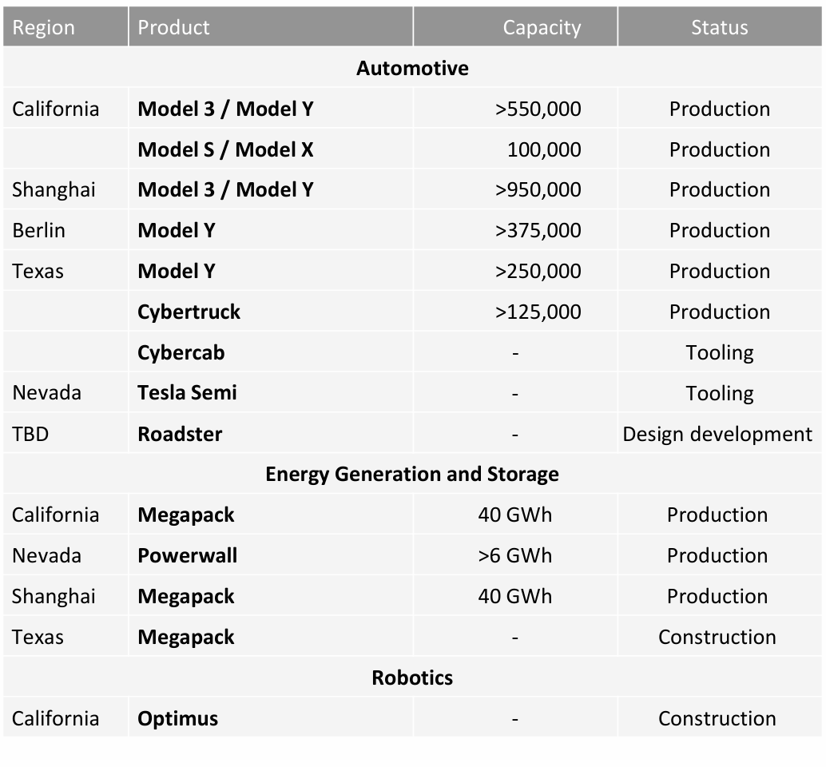

1: Stock Prediction (40 points)
1.1 Predict the direction of Tesla (NASDAQ: TSLA) stock price over the next 5 trading days following the earnings release. 20 points
Output must be: "up" or "down"
1.2 Predict the percentage price change for Tesla stock over the next 5 trading days. 20 points
Output must be a percentage number

Q2: Data Processing Ability (20 points)
Answer the following questions based on the production capacity table:
2.1 What is the total production capacity for Model 3 and Model Y at the Shanghai factory? (5 points)
2.2 Which product is currently in the "Construction" status, and at which location? (5 points)
2.3 What is the production capacity for Cybertruck at the Texas factory? (5 points)
2.4 What is the production capacity for Megapack at the Shanghai facility, and what is its current status? (5 points)

Q3: Information Processing Ability (20 points)
Based on the earnings release, identify and explain:
3.1 The three strongest positive signals that would support a bullish outlook on Tesla stock. For each, cite the specific data point and its source. (12 points)
3.2 The one potential concern or risk factor that could temper the positive outlook. (8 points)

Q4: Constraint Consistency (20 points)
Your response must follow these rules:
C1 Output must be in a single JSON object containing all answers
C2 Q1.1 must contain direction field with "up" or "down"
C3 Q1.2 must contain a percentage only
C4 Q2 answers must be in a data_answers object with numeric values where applicable
C5 Q3 answers must be in a signals array with each signal containing signal, data_point, source, and impact fields
C6 Q3.2 must be in a risk_factors array

ANSWERS
Q1
1.1: down (20 points)
1.2: correct answer is 2%
≤ 20% (1.6% - 2.4%) 20 points
20% - 50% (1.0% - 3.0%) 15 points
50% - 100% (0% - 4%) 10 points
100% - 200% (0% - 6%) 5 points
>200% (<0% or >6%) 0 points
Anti-cheat: if answer is 0% 0 points

Q2
2.1: >950,000 (5 points)
2.2: Megapack; Texas (5 points)
2.3: >125,000 (5 points)
2.4: 40 GWh; Production (5 points)

Q3
3.1 Expected Signals:
Record energy storage deployments: "achieved our highest quarterly energy storage deployments, driven by record Megapack deployments. Total gross profit rose to a record $1.1 billion, marking the fifth consecutive record quarter" (from Energy Generation and Storage section) (4 points)

Strong APAC regional performance: "The APAC region continued to show strength across multiple markets and set a record for deliveries in the quarter" (from Automotive section) (4 points)

Optimus robot production scale-up: "Preparations are underway for the first production line... with start of production planned before the end of 2026 and eventual planned capacity of 1 million robots per year" (from Robotics section) (4 points)

3.2 Risk Factor:
Expected Risk: "While automotive sales declined sequentially" (from Automotive section) or "automotive sales declined sequentially despite gross margin improvement" (8 points)

4:
C1 5points
C2-C6: 3 points each.

